**Land use Landcover Change Detection Analysis for Kericho County (2014-2023).**

**Abstract**

Land use and land cover change detection analysis is the process of studying and mapping the changes in the way land is being used and the vegetation cover over a specific area over a period of time. In the case of Kericho County from 2014 to 2023, this analysis would involve examining how the land in the county has been utilized and how the vegetation cover has changed over this 10-year period. To conduct this analysis, satellite images and remote sensing data would be used to compare the land use and land cover of Kericho County in 2014 with that of 2023. Various techniques and algorithms would be applied to detect and map the changes that have taken place. This could include the detection of deforestation, urban expansion, agricultural expansion, and changes in natural vegetation cover. The results of this analysis can provide valuable insights into the trends and patterns of land use and land cover change in Kericho County over the past decade. It can help in understanding the impact of human activities and natural processes on the county's environment and natural resources. This information is crucial for making informed decisions about land management, conservation, and sustainable development in the region. In conclusion, the land use and land cover change detection analysis for Kericho County from 2014 to 2023 is an important tool for monitoring and understanding the dynamics of the county's landscape. By analyzing the changes in land use and vegetation cover, this study can contribute to informed decision-making and planning for the sustainable management of the county's resources and environment.

**CHAPTER ONE**

**1.1 Introduction**

Land use refers to the human activities and purposes for which land is utilized , such as agriculture ,urban development,foresty or transportation. On the other hand, landcover pertains to the physical characteristics on the earths surface including natural features like forest, waterbodies and bare land.

Land use and landcover classification involves categorizing different types of land based on the attributes.This process help us understand the spatial distribution of land features,monitor changes over time ,and make informed decision for sustainable land management.

**1.1.1 Background of the study area**

Kericho County is located in the Rift Valley region of Kenya and has a rich historical background. The area was originally inhabited by the Kipsigis people, who are known for their expertise in agriculture and their unique traditional practices and customs. During the colonial period, the British first arrived in the area in the late 19th century. They were attracted by the fertile soil and favorable climate for tea farming. Subsequently, the British established large tea plantations in Kericho, which significantly altered the landscape and economy of the region. The economic boom that came with the tea industry also led to the construction of the Kenya-Uganda Railway, which passed through the county. This connection to the railway system brought further development and growth to Kericho. In the post-independence era, Kericho continued to be a major hub for tea production and was recognized as one of the leading tea-growing regions in the world.

**1.1.2 Location of Study Area**

Kericho County is located in the Rift Valley region of Kenya. It is situated in the highlands and is known for its picturesque tea plantations and cool climate. The county is bordered by Bomet County to the north, Nakuru County to the east, Kisumu County to the west, and Nandi and Narok counties to the south. The county is predominantly rural, with agriculture, particularly tea farming, being the main economic activity. The major town in Kericho County is Kericho town, which serves as the administrative and commercial center of the county.

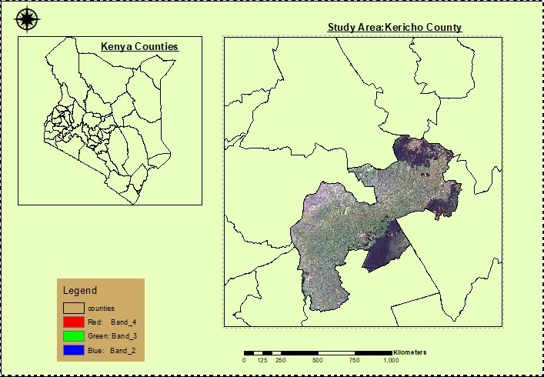

**1.1.3 Significance of the study**

Studying land use and land cover change detection analysis for Kericho County using supervised classification helps to understand the dynamics of the landscape in terms of changes in land cover and land use over time. This information is crucial for making informed decisions related to urban planning, resource management, and environmental conservation.

Conducting this type of analysis allows us to monitor the impacts of human activities on the natural environment. By identifying trends in land use and cover change, we can assess the level of deforestation, urbanization, agricultural expansion, and other factors that may be contributing to environmental degradation.

Studying land use and land cover change detection analysis using supervised classification for Kericho County is significant because it enables us to promote sustainable development, preserve natural habitats, and make informed decisions about the management of land and resources in the region.

It also provides a basis for implementing effective land use policies and interventions to mitigate the negative impacts of land cover and land use changes on the environment and society.

**1.1.4**  **Objectives**

1.To perform Change Detection techniques on Kericho County and extract results.

2.To perform classification(Supervised Classification) and get the results for the Analysis.

3.To assess the Accuracy of the Supervised Classification for the two years that will be used for determining the changes.

4.To compose Maps, Graphs ,Histograms, Tables important for Analysis.

5.To deduce results from the classified graphs.

6.To recommend some actions that need to be undertaken regarding the land use change that has occurred.

**2.0 CHAPTER TWO**

**2.1** **Data**

**Secondary data**

Landsat image:2014

Landsat image:2023

**2.2**  **Method**

* Image Acquisition; acquisition of the Landsat images from the Earth Explorer geoportal.
* Subset Kericho county and clipping the Imagery using the Kericho county shapefile for each year(2014 &2023).
* Use different band combination to help come up with Training samples for Different Land use classes example the agricultural land,water,Built up Areas,Forests.
* Performing Supervised classification
* Ground Truthing with the help of Google Earth to access the Accuracy and Kapa coeficicient of the Supervised Classification.
* Prepare Land use landcover map(Map Composition)
* Perform Raster to vector Conversion on each of the classified LULC map followed by Change detection by including area,change and percentages fields
* Interpret and Perform Analysis on the Results.
* Prepare land use /Landcover Change Detection Map.

**3.0 CHAPTER THREE**

**3.1Results**

**Scatterplots**

The scatter plot showed well separated clusters for water and built-up areas land use classes indicating all the seven bands indicating good separability hence high level of classification accuracy.

The scatterplots for Forest and agricultural land land use classes showed partial overlap of the classes

**Impact Of Cloud On The Classification**

We didn't capture any clouds and cloud cover during supervise classification and the following are impacts of clouds on classification.

**Clouds obstruct the view**:When optical satellite imagery is affected by cloud cover, it results in missing or distorted information about the land surface. This may lead to misclassifications during supervised classification

**Reduced Spectral information:** Clouds block sunlight affecting the spectral reflectance patterns captured by sensors. As a result the ability to differentiate landcover classes diminishes.

Results: Accuracy Assessment for Kericho Supervised Classification 2014

|  |  |  |  |  |  |  |
| --- | --- | --- | --- | --- | --- | --- |
|  | Forest | Agricultural land | Built up areas | water | Bare land | Total(user) |
| Forest | 15 | 0 | 0 | 0 | 0 | 15 |
| Agricultural land | 0 | 23 | 0 | 0 | 1 | 24 |
| Built up areas | 1 | 4 | 6 | 0 | 0 | 11 |
| Water | 0 | 1 | 0 | 3 | 1 | 5 |
| Bare land | 0 | 4 | 0 | 0 | 15 | 19 |
| Total (producer) | 16 | 32 | 6 | 3 | 17 | 74 |

**Overall Accuracy**= Total Number of Correctly classified pixels (Diagonal)

Total number of Reference Pixels

62/74*100%=83.7837

=83.78%

**User Accuracy**= Number of correctly Classified pixels in Each Category

Total Number of correctly classified pixels (row total)

**User Acurracy**

Forest=15/15*100=100%

Agricultural Land=23/24*100=95.83%

Built up areas=6/11*100=54.55%

Water=3/5*100=60%

Bare land=15/19*100=78.95%

**Producer Accuracy**

Forest=15/16*100=

Agricultural Land=23/32*100=71.88%

Built up areas=6/6*100=100%

Water=3/3*100=100%

Bare Land=15/17=88.24%

**Kappa**

TS*TCS-sum(column Total*Row Total) X100

TS(TS)-sum(Column Total*Row Total)

(62*74)-((15*16)+(23*32)+(6*6)+(3*3)+(15*17)) X 100

5476-((16*15)+(32*24)+(6*11)+(3*5)+(17*19)

=81.50%

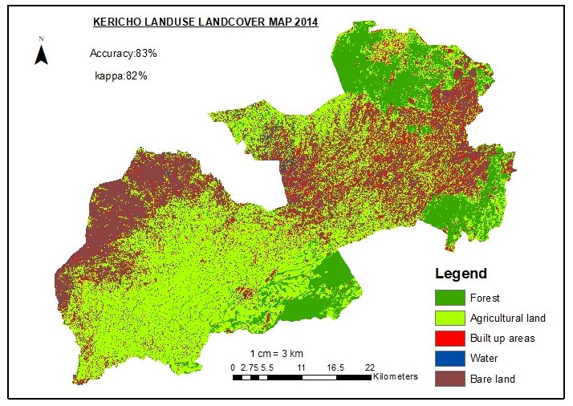

|  |  |  |
| --- | --- | --- |
| Classes | Area_2014_in Square meters | Percentage(%) |
| Forest | 334783326.3 | 15.91861106 |
| Agricultural Land | 985389061.4 | 46.85426058 |
| Built up Areas | 86753061.13 | 4.125020961 |
| Water | 10549794.74 | 0.501632148 |
| Bare land | 685618582.1 | 32.60047525 |

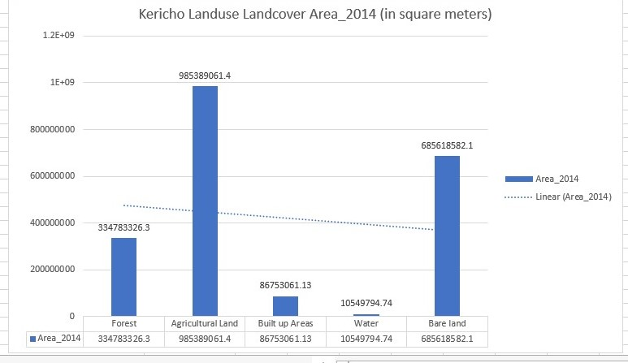

***Results****:*  ***Kericho 2023 Supervised Classification (Accuracy& Kappa Coefficient)***

|  |  |  |  |  |  |
| --- | --- | --- | --- | --- | --- |
|  | Forest | Tea | Built up | Water | Total(User) |
| Forest | 11 | 0 | 0 | 0 | 11 |
| Agricultural land | 0 | 7 | 0 | 0 | 7 |
| Built up | 1 | 2 | 9 | 0 | 12 |
| Water | 0 | 0 | 0 | 1 | 1 |
| Total(producer) | 12 | 9 | 9 | 1 | 31 |

Overall Accuracy=29/31*100=93%

User Accuracy

Forest=11/11*100=100%

Agricultural land=7/7*100=100%

Built up=9/12*100=75%

Water=1/1*100=100%

Producer Accuracy

Forest=11/12*100=91.66%

Agricultural land=7/9*100=77.77%

Built up=9/9*100=100%

Water=1/1*100=100%

Kappa coefficient

TS*TCS-sum(column Total*Row Total) X100

TS(TS)-sum(Colum Total*Row Total)

(28X31)-((11x11)+(7X7)+(9X12)+(1X1) X100

1. ((12X11)+(9X7)+(9X12)+(1X1)

589/657*100=89.6499%

=89%

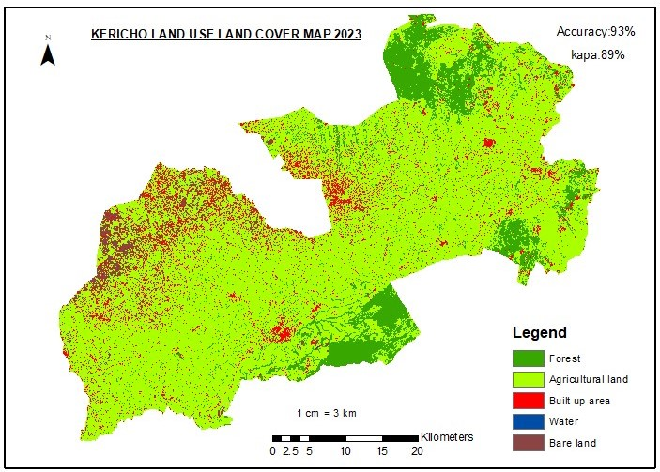

|  |  |  |
| --- | --- | --- |
| Classes | Area_2023_in Square meters | Percentage(%) |
| Forest | 263242509.2 | 12.51690215 |
| Agricultural Land | 1616320767 | 76.85433843 |
| Built up Areas | 144844029.9 | 6.887180023 |
| Water | 66942.0026 | 0.003183021 |
| Bare land | 78622076.63 | 3.738396369 |

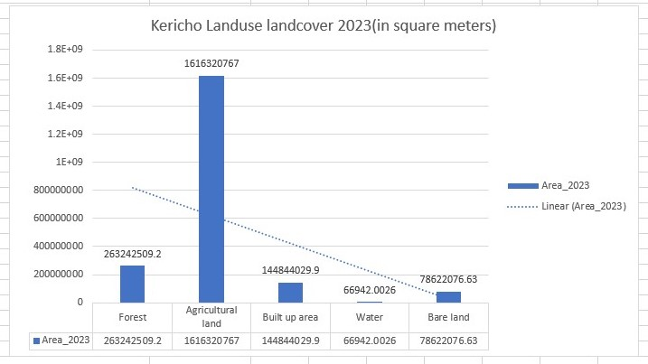

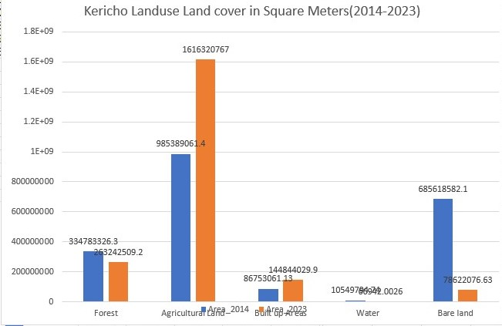

**Land Use Land Cover Change(2014-2023)**

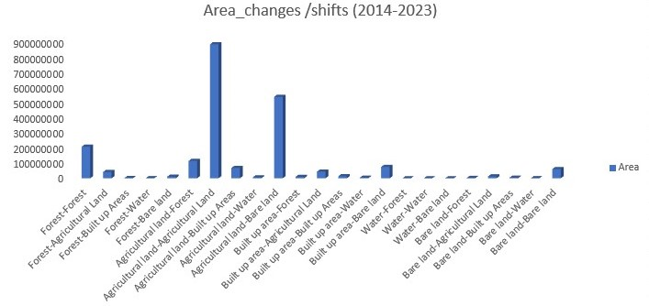

|  |  |
| --- | --- |
| **Change** | **Area_ meters square** |
| Forest-Forest | 208982961.3 |
| Forest-Agricultural Land | 41450448.95 |
| Forest-Built up Areas | 1526245.417 |
| Forest-Water | 539685.3684 |
| Forest-Bare land | 10673402.65 |
| Agricultural land-Forest | 114976438 |
| Agricultural land-Agricultural Land | 887397597.3 |
| Agricultural land-Built up Areas | 68194397.9 |
| Agricultural land-Water | 6112174.417 |
| Agricultural land-Bare land | 539146217.2 |
| Built up area-Forest | 9033670.484 |
| Built up area-Agricultural Land | 43930835.19 |
| Built up area-Built up Areas | 13384009.99 |
| Built up area-Water | 3567750.081 |
| Built up area-Bare land | 74835750.44 |
| Water-Forest | 734.8240145 |
| Water-Water | 62253.94845 |
| Water-Bare land | 3953.230137 |
| Bare land-Forest | 1698593.943 |
| Bare land-Agricultural Land | 12328484.23 |
| Bare land-Built up Areas | 3593747.59 |
| Bare land-Water | 249831.3693 |
| Bare land-Bare land | 60710250.6 |

**4.0 CHAPTER FOUR**

**4.1 Conclusion**

Land use land cover change detection analysis for Kericho County between 2014 and 2023 reveals significant changes in the landscape and the way the land is being utilized. The analysis shows that there has been a considerable expansion of agricultural land in the county, particularly in the form of tea plantations. This change is a result of the county's prime agricultural conditions and the increasing demand for tea as a cash crop.

There has been a noticeable decrease in forest cover and natural vegetation, mainly due to expansion of agricultural activities. This has led to environmental concerns such as habitat loss, soil erosion, and decreased biodiversity, which can have long-term impacts on the ecosystem and the local communities.

The results also indicate a shift in land use from bare land to agriculture , indicating the county's growing economy in terms agricultural extensive. This trend is accompanied by an increase in infrastructure and residential developments, as well as commercial activities, reflecting population growth and economic expansion in the region.